 | Weedle # 1 | Pidgey # 2 | 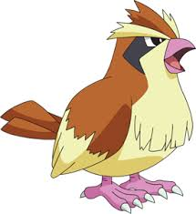
 | Rattata # 3 | Zubat # 4
 | Catapie # 5 | Drawzee # 6 | 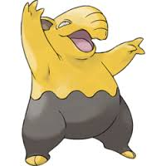
 | Ghastly # 7 | Eevee # 8 | 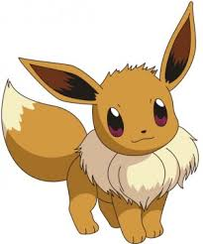
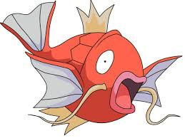 | Magikarp # 9 | Ekans # 10

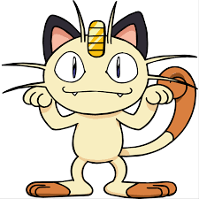 | Meowth # 11 | Clefairy # 12
 | Horsea # 13 | Jigglypuff # 14
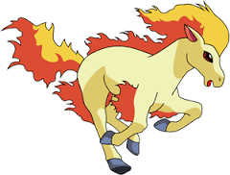 | Ponyta # 15 | Vulpix # 16
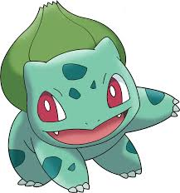 | Bulbasaur # 17 | Squirtle # 18
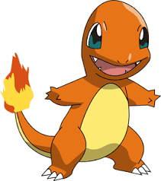 | Charmander # 19 | Pikachu # 20

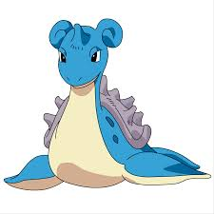 | Lapras # 21 | Slowbro # 22 | 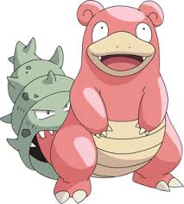
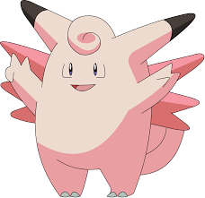 | Clefable # 23 | Victreebel # 24
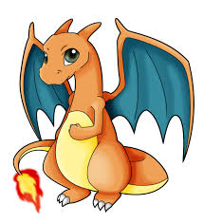 | Charizard # 25 | Venusaur # 26 | 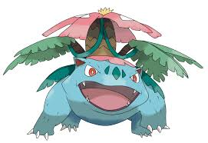
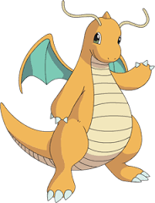 | Dragonite # 27 | Zapdas # 28 | 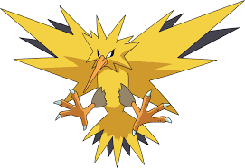
 | Ditto # 29 | Mew # 30
How do I collect Pokemon?

When you have finished reading your reading book and have updated your reading record, you may scan the QR code in the back of the book to see what Pokemon you have collected. You can collect your Pokemon from a trusted Pokemon Keeper in Y6.

Do I have to have my reading record updated?
Yes. Whilst we know that you wouldn’t take a book home without reading it – purely to catch a Pokemon – others may not be as trustworthy! After reading your book, write it in your reading record and ask a parent or guardian to sign to confirm that you have read the book.

What do I do with my Pokemon?
There are four different saving charts that you can use to stick your Pokemon. These can be kept at school or at home if you prefer. You will be able to upgrade at special times too, so if you have 10 Weedles (being the most common Pokemon), you can swap it for something special – look out for exciting promotions!

What if I don’t like the book I picked from the library?
If you don’t like the book and would prefer not to read it, just exchange your library book the next day. It’s not a problem. Will you be able to catch the Pokemon I hear you ask? No.

Why can’t I find one of the rarer Pokemon?
Well, if they were easy to find, everyone would have one and it wouldn’t be rare! Mew is in high demand and if you find it – lucky you – but don’t tell anyone which book you found Mew in!

What else do I need to know?
Your Pokemon can’t do battle… but what if you created some comprehension style questions about the book you have read? We would love that! Put your questioner head on, get thinking and you will gain house points. Should someone else read the same book and attempt your comprehension style questions, they will earn house points and you will earn even more! It’s a win, win situation!

Enjoy!

