**Mathematics**

I will have the chance to sort and group objects or materials and explain why I have done this. I will be able to play with lots of resources indoors and outdoors and make comparisons in things like height, weight, size and texture.

I will be able to use words like under, on top, between and in front to tell where things are and to put things in order when I play. I will have opportunities to build and make things with shapes and talk about what these shapes look like.

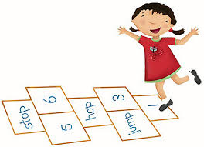I will be able to use numbers when I play to count and match things to each other. I will begin to learn about adding things together or taking them away. I will learn to recognise numbers all around me and use them confidently in play and games. I will start to be able to put events in order and think about what happens next during the day. I will get the chance to notice patterns in lots of situations and have a go at making patterns myself. I will get to use all I know about Maths to solve practical problems when doubling, halving and sharing.