Year 2 Newsletter
Autumn Term 2017

Dear Parent,

Welcome back to the routine of school life. The children have settled back in wonderfully and it has been wonderful to see them all in school uniform and grown 2 inches taller!

Throughout the year the children will be reading lots of books by the author Roald Dahl. These are challenging books. Reading books should be taken home every night and weekends. We would like all children to read for at least 15 minutes each night, this might be their school book or a magazine or even the local newspaper. Please discuss the language with your child, as you will be surprised what they don’t really understand. In school the children ask for words to be clarified, if they are unsure of the meaning. In Year 2 we encourage independence, the children need to take their reading books out of their bags and hand them in to be changed. If your child forgets please do not hesitate to catch us and we will make sure the children are prompted.

In English the children will be continuing to improve their work, writing for a variety of purposes. This term we are focusing on all children using the cursive handwriting script and ensuring all sentences begin with a capital letter and end with a full stop without being prompted. They will be encouraged to use dictionaries to check their spellings and spellings will be sent home each week to extend their learning. We will also be doing daily phonic lessons so the children continue to understand spelling patterns and know when to use them.

In Maths there will be a strong focus on mental maths. The children will work on place value, counting and properties of numbers. They will be developing mental calculation strategies for + and – and solving problems relating to money, shape and measure. Please work on consolidating the + and – number sentences attached to this newsletter at home with your child as it does help them to develop a quicker speed in maths.

In Science we are studying ‘Living Things and Their Habitats’ where we will be looking at what makes a habitat suitable and how different animals fit within their food chains. We will be encouraging all children to develop their personal research using the internet and books, photographs and asking questions of others.

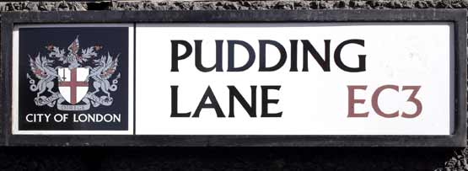During the Autumn term we will be studying the Great Fire of London and Parliament. The children will be learning about how the fire started and eventually how it was defeated. During this time the children will be investigating how the fire brigade are vital in situations like this.

Our PE sessions will be on a Friday. The children have a school PE kit, but they will need to bring in from home a pair of plimsolls or trainers.

We are looking forward to an exciting term and hope the children are too. If you have any worries or questions, please do not hesitate to contact us and we will do our best to solve the issue.

Thank you

Mrs Padgett, Miss Barker & Miss Gregory

Important Dates for the forthcoming term

Date | Time | Event
Thursday 14th September | 8.45am or 2.30pm | Year 2 Parent Meeting – Please attend one of these sessions.
Tuesday 19th September | 9am | Children only will be going to Hemlington Library
Thursday 28th September | All day | Children only  A photographer will be in school taking photos for the website
Friday 29th September | 9am | PTFA coffee morning– any parents who would like to be part of a fund raising group for school please feel to drop in for this session.
Thursday 12th October | 9:30-12pm | Children only  Great Fire of London workshop - £1 contribution per child
Monday 16th October | 1pm | Children only  Fire Brigade in school to talk to the year 2 children.
Friday 20th October |  | Children break up for October half term
Monday 30th October | All day | PD Day children not in school

New dates will be sent out during the academic year.

