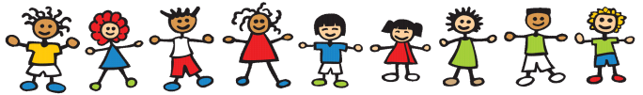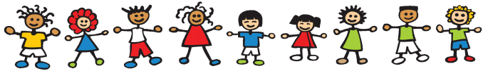

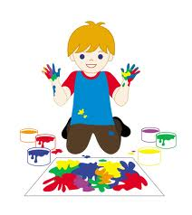

Expressive Arts and Design

I will have the opportunity to express my own thoughts, ideas and feelings through drawing, painting, model making, woodwork and by using clay. I will use lots of tools to see how they work and what they can do and will use natural and manmade materials to design and make my own creations, models and structures. I will be able to explore colours, shapes and textures of flat and solid shapes using all of my senses. I will get the opportunity to see interesting objects, pictures and people, feel different moods, taste a variety of flavours, smell an assortment of things and hold or touch things to see how they feel.

I will be able to listen to and make my own music, dance, sing songs and take part in imaginative role play with my friends. It will be nice to find the right means of expression and choose the words to share these times with my friends, my teachers and my family as I play and explore the world around me.