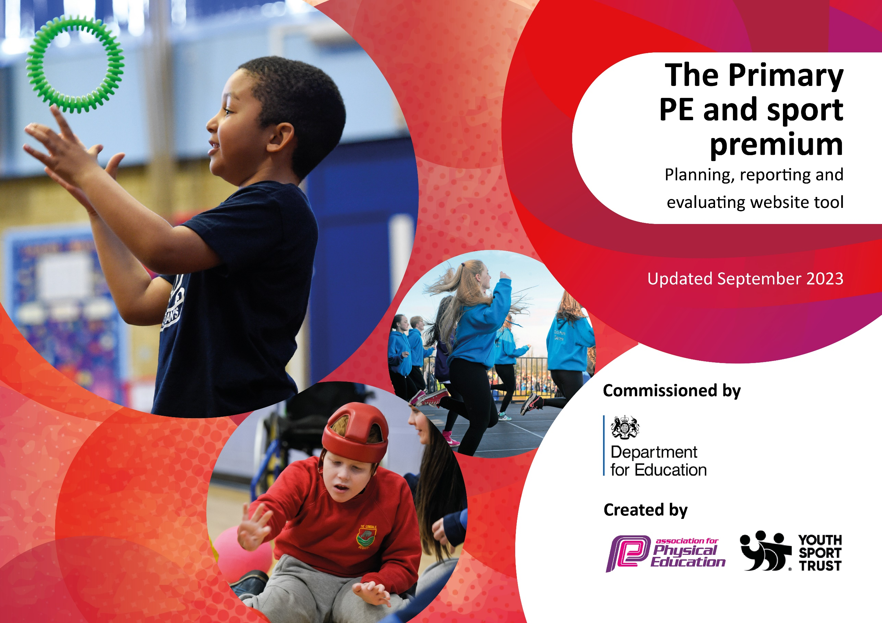

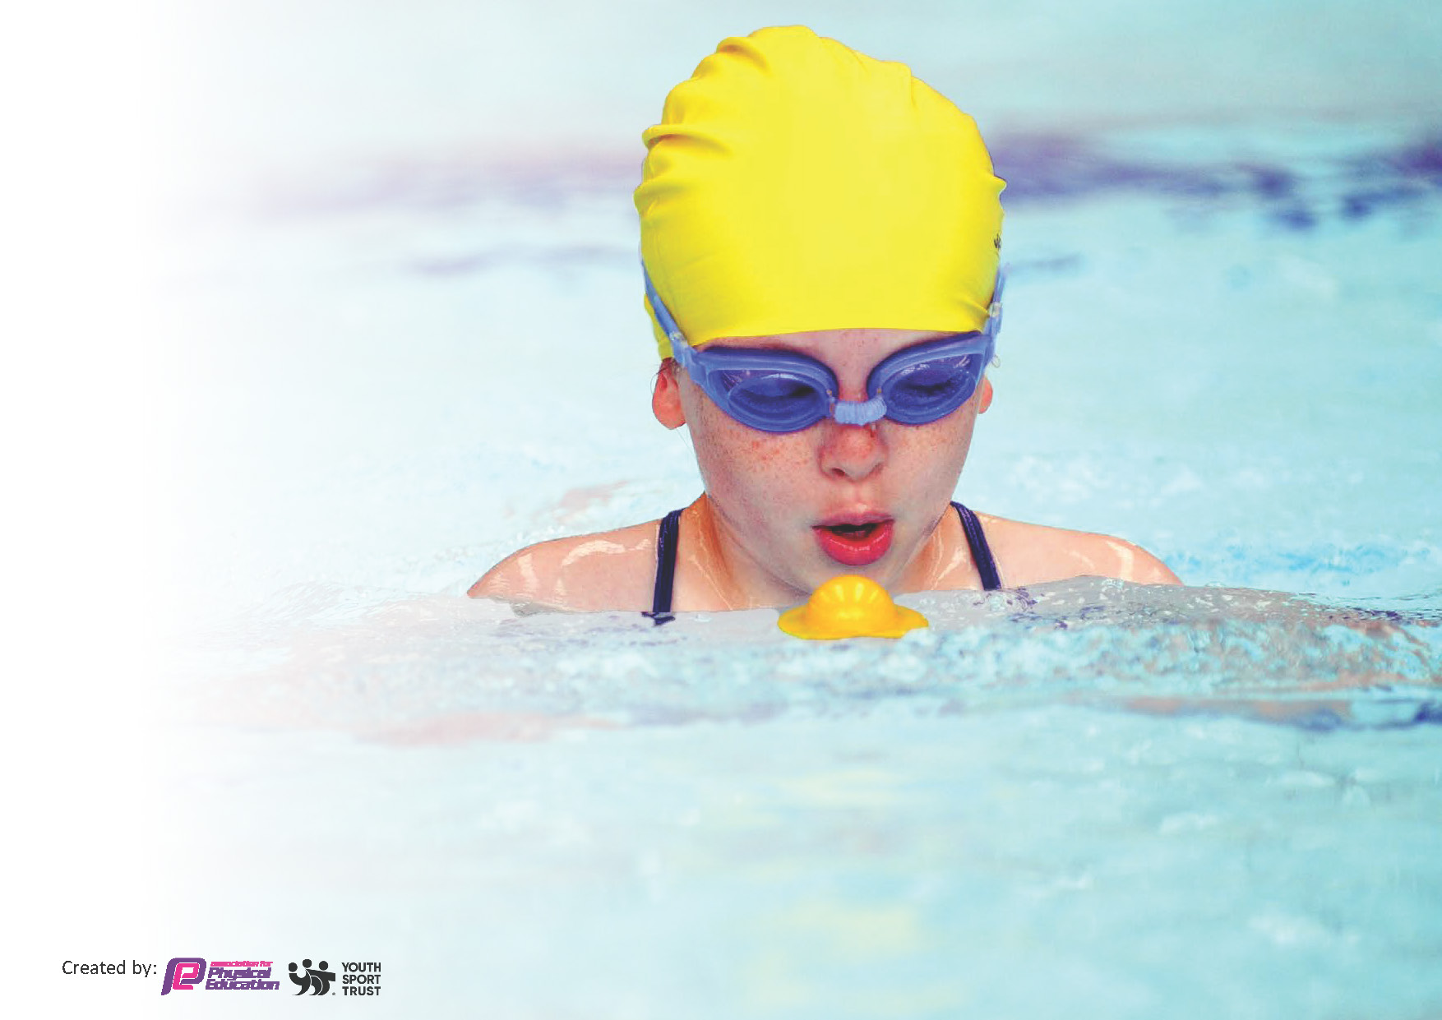
This template can be used for multiple purposes:
by:
- It enables schools to effectively plan their use of the Primary PE and sport premium
- It helps schools to meet the requirements (as set out in guidance) to publish information on their Primary PE and sport premium
- It will be an effective document to support Ofsted inspections enabling schools to evidence progress in Physical Education (PE) and evidence swimming attainment, which forms part of the PE National Curriculum. We would recommend schools consider
the Intent, Implementation and Impact of any spend, as examined within the Education Inspection Framework.

It is important that your grant is used effectively and based on school need.

Schools must use the funding to make additional and sustainable
improvements to the quality of the PE, School Sport and Physical Activity (PESSPA)
they offer. This means that you should use the Primary PE and sport premium to:

- Build capacity and capability within the school to ensure that improvements made now will benefit pupils joining the school in future years
- Develop or add to the PESSPA activities that your school already offers.

The Primary PE and sport premium should not be used to fund capital spend projects; the school’s core budget should fund these. Further detail on capital expenditure can be found in the updated Primary PE and sport premium guidance.

The Primary PE and sport premium guidance, outlines 5 key priorities that funding should be used towards. It is not

necessary that spending has to meet all the key priorities, you should select the priorities that you aim to use any funding towards.

Although completing this template is not a requirement for schools, schools are required to publish details of how they spend this funding. Schools must also outline what the impact this funding has had on pupils’ PE and sport participation and attainment and how any spending will be sustainable in the future. All funding must be spent by 31st July 2024.

The Department for Education has worked closely with the Association for Physical Education (afPE) and the Youth Sport Trust (YST) to develop this template and encourages schools to use it. This template is an effective way of meeting the reporting requirements of the Primary PE and sport premium.
Review of last year’s spend and key achievements (2022/2023)

We recommend you start by reflecting on the impact of current provision and reviewing your previous spend.

Key achievements to date until July 2024 | Areas of further improvement and baseline evidence of need for 2023-2024
- Hemlington Hall has achieved a Gold Games Mark 2023. This demonstrates our commitment to growing our children’s engagement with sport and PE. This is our second consecutive year of achieving the gold standard.  - More children have attended sporting events across the year and this is becoming a more inbuilt part of our PE/Sport offer to children.  - Our school offers a wide range of extra-curricular sport clubs and holiday clubs, which are always very popular.  - Our Year 6 children attended swimming top-up sessions to ensure they achieved at 25m.  - In June 2023, we participated in the National Sports Week, in which children had the opportunity to take part in a variety of activities. | - The PE scheme (Get Set 4 PE) has much improved our PE provision, however the PE lead needs additional time to monitor and assure impact this year.  - Our new PE Lead (Mr Bennett) will work alongside the previous lead (Miss Solomon) to ensure consistency in our PE curriculum.  - Commit to delivering 30 active minutes for every child, every day.  - Create a positive experience to support character development of targeted young people, including Sport Council and Play Leaders.  - Plan and deliver an active School Sports Week to celebrate the 2024 Olympic Games.

Key priorities and Planning
This planning template will allow schools to accurately plan their spending.

Action – what are you planning to do | Who does this action impact? | Key indicator to meet | Impacts and how sustainability will be achieved? | Cost linked to the action
Introduce lunchtime sport sessions/activities for pupils. | Lunchtime supervisors / play leaders, coaches - as they need to lead the activity.  Pupils- as they need to participate in the activities. | Key indicator 2 -The engagement of all pupils in regular physical activity – the Chief Medical Officer guidelines recommend that all children and young people aged 5 to 18 engage in at least 60 minutes of physical activity per day, of which 30 minutes should be in school.  Key indicator 4: Broader experience of a range of sports and activities offered to all pupils. | More pupils meeting their daily physical activity goal, more pupils encouraged to take part in PE and Sport Activities.  Lunchtime zones have been established on the yard, with football, tennis and other activities are being utilized at lunchtimes offering children the chance to try new sports and work towards their ‘active 30’. | £1000 costs for additional coaches/ play leaders to support lunchtime sessions.  £2000- new equipment.
Continue to develop more active playtimes- with children able to be more physical in non-traditional ways. | All teaching staff/TAs- as they need to monitor/supervise playtime activities.  Sport Coach- as they will plan and deliver play time activities.  Pupils- as they will participate in a variety of activities.  Sport Play Leaders- children will take part in training sessions to deliver activities to other pupils, help promote a more active playtime. | Key indicator 2 -The engagement of all pupils in regular physical activity.  Key indicator 3- The profile of PE and Sport is raised across the school as a tool for whole school improvement.  Key indicator 4: Broader experience of a range of sports and activities offered to all pupils. | More pupils meeting their daily physical activity goal, more pupils encouraged to take part in PE and Sport Activities.  New equipment has been purchased along with playground markings to offer a wider range of activities to help stimulate and embed the fundamentals of basic movement.  Sports leaders and y6 pupils have been trained in how to run a whole school sports festival for our sports week. | £2000- new equipment.  £500- training sessions for the Sport Play Leaders.  Enhance playground markings-
Improve the physical activity of children outside of school term and national curriculum time. | Sport coaches and Teaching staff- as they will need to plan and deliver the sessions.  Pupils- as they will take part in the sports clubs/activities. | Key Indicator 2- The engagement of all pupils in regular physical activity.  Key indicator 4: Broader experience of a range of sports and activities offered to all pupils. | More pupils participating in physical activity.  OSF funding and a new variety of half term clubs have increased the engagement and signups for our half term clubs. The new equipment has offered a variety of sports and activities that the children may not have experienced outside of the school building. | £2500
Further develop staff confidence in teaching a range of exciting, engaging sports | All staff- Teachers and TAs. | Key Indicator 1: Increased confidence, knowledge, and skills of all staff in teaching PE and sport.  Key indicator 3- The profile of PE and Sport is raised across the school as a tool for whole school improvement.  Key Indicator 4- Broader experience of a range of sports and activities offered to all pupils. | Primary teachers more confident to deliver effective PE supporting pupils to undertake extra activities inside and outside of school.  Ongoing CPD with Mr Bennett and sports coaches on ways to engage children during their PE time. Youth sports trust and online CPD has been a useful tool to pass on knowledge to staff. | £1000 (including Get Set 4 PE subscription)  £1000 new equipment
Increase the variety of extra-curricular school sport, provided by the sports coach / teachers/ external providers. | Sports coach, play leaders- they will plan and deliver a range of activities. | Key Indicator 2- engagement of all pupils in regular physical activity.  Key Indicator 4- Broder experience of a range of sports and activities offered to all pupils. | All pupils will have the opportunity to take part in a variety activity.  Extracurricular activities such as breakfast club sports, lunchtime sports provision and an increased variety of after school clubs have not only increased in participants, but the variety of carefully planned out sports has allowed for more children from different backgrounds to engage and develop a love and understanding of sport. We had 64 sign ups for boogie bounce and 36 of those are children who have not before signed up to a club. | £2500
To ensure that pupils have the opportunity to attend competition over the course of the year, when possible. | Pupils- children will have the opportunity to participate in competitive sport and represent our school.  Staff- they will supervise pupils during the competitions. | Key Indicator 2- engagement of all pupils in regular physical activity.  Key Indicator 4- Broder experience of a range of sports and activities offered to all pupils.  Key Indicator 5- Increased participation in competitive sport. | All children will have the opportunity to participate in competitive sport and represent our school, in a variety of activities.  Summer athletics competitions, have allowed the whole school to attend in June 2024. These competitions have sent a variety of children to compete and in some cases for the first time. | £1500- Middlesbrough School Games Partnership.  Cost for new sports kits  £1000 transport costs.
Implement intra- school competition throughout the year, following the values of the School Games. | Pupils- children will have the opportunity to participate in competitive sport and represent our school.  Staff- they will supervise pupils during the competitions. | Key Indicator 2- engagement of all pupils in regular physical activity.  Key Indicator 4- Broder experience of a range of sports and activities offered to all pupils.  Key Indicator 5- Increased participation in competitive sport. | All children will have the opportunity to participate in competitive sport.  We have also planned to run an inter school competition during sports week 2024 to allow children who have not participated in a competition outside of school to attend. | £500
To participate in National School Sports Week. | Sport coaches and Teaching staff- as they will need to plan and deliver the sessions.  Pupils- as they will take part in the sports clubs/activities.  External Sports coaches | Key Indicator 1: Increased confidence, knowledge, and skills of all staff in teaching PE and sport.  Key Indicator 2- engagement of all pupils in regular physical activity.  Key indicator 3- The profile of PE and Sport is raised across the school as a tool for whole school improvement.  Key Indicator 4- Broder experience of a range of sports and activities offered to all pupils.  Key Indicator 5- Increased participation in competitive sport. | All pupils will have the opportunity to take part in a variety activity.  Sports week has been planned for July 2024 with a range of different sports such as UV multi sports, scooter safety, boogie bounce, obstacle courses, healthy eating and more. | £1500
Key achievements 2023-2024
This template will be completed at the end of the academic year and will showcase the key achievements schools have made with their Primary PE and sport premium spending.

Activity/Action | Impact | Comments
Participation in out of school athletics competition.  Intra school competition in line with school games awards.  Increase the variety of extra-curricular school sport, provided by the sports coach / teachers/ external providers.  Continue to develop more active playtimes- with children able to be more physical in non-traditional ways. | Key Indicator 2- engagement of all pupils in regular physical activity.  Key Indicator 4- Broder experience of a range of sports and activities offered to all pupils.  Key Indicator 5- Increased participation in competitive sport.  Key Indicator 2- engagement of all pupils in regular physical activity.  Key Indicator 4- Broder experience of a range of sports and activities offered to all pupils.  Key indicator 2 -The engagement of all pupils in regular physical activity.  Key indicator 3- The profile of PE and Sport is raised across the school as a tool for whole school improvement.  Key indicator 4: Broader experience of a range of sports and activities offered to all pupils. | Allowing children to experience the feeling of representing Hemlington Hall academy, in some cases for the first time.  As well as the external competitions we have successfully ran an inter school competition for those who didn’t get to experience the athletics competitions. This helps to target a wider range of pupils and to offer the chance to compete alongside their friends in a fun, safe and competitive setting.  Extracurricular activities such as breakfast club sports, lunchtime sports provision and an increased variety of after school clubs have not only increased in participants, but the variety of carefully planned out sports has allowed for more children from different backgrounds to engage and develop a love and understanding of sport. We had 64 sign ups for boogie bounce and 36 of those are children who have not before signed up to a club.  Sports council we consulted on how we can improve our lunchtime sports and play provisions. They felt the equipment was insufficient and that they were bored and had nothing to do. Lunchtime zones have been established on the yard, with football, tennis and other activities are being utilized at lunchtimes offering children the chance to try new sports and work towards their ‘active 30’. In turn, children are looking forward to their active lunch times more than before. Behaviour has improved on the playground as children are occupied with relevant challenges.

Swimming Data
Meeting National Curriculum requirements for swimming and water safety.
Priority should always be given to ensuring that pupils can perform safe self-rescue even if they do not fully meet the first two requirements of the National Curriculum programme of study

Question | Stats: | Further context  Relative to local challenges
What percentage of your current Year 6 cohort can swim competently, confidently and proficiently over a distance of at least 25 metres? | % | Use this text box to give further context behind the percentage.  e.g., 30% - we are struggling to get pool space due to our local pool closing so we have had to use a much smaller local school pool. We have had to limit the number of pupils attending swimming lessons during one term which means some pupils have attended fewer swimming lessons than others.
What percentage of your current Year 6 cohort can use a range of strokes effectively [for example, front crawl, backstroke, and breaststroke]? | % | Use this text box to give further context behind the percentage.  e.g., Even though your pupils may swim in another year please report on their attainment on leaving primary school at the end of the summer term 2024

What percentage of your current Year 6 cohort are able to perform safe self-rescue in different water-based situations? | % | Use this text box to give further context behind the percentage.
If your schools swimming data is below national expectation, you can choose to use the Primary PE and sport premium to provide additional top-up sessions for those pupils that did not meet National Curriculum  requirements after the completion of core lessons. Have you done this? | Yes/No
Have you provided CPD to improve the knowledge and confidence of staff to be able to teach swimming and water safety? | Yes/No

Signed off by:

Head Teacher:
Subject Leader or the individual responsible for the Primary PE and sport premium: | Donna Solomon
Governor:
Date: | October 2023

